**ST. THEREZA NAMIRYANGO GIRLS’ BOARDING PRIMARY SCHOOL**

**END OF TERM I CONTINUOUS ASSESSMENT 2024**

**P.3 LITERACY I**

**TIME ALLOWED: 2 HOURS 15 MINUTES**

**NAME__________________________________________STM__**

**SECTION A**

1. Name any one example of animals used for transport.

**___________________________________________________________**

2. Why do we need light in the classroom when learning?

**___________________________________________________________**

3. How many legs has a housefly?

**___________________________________________________________**

4. What causes day and night?

**___________________________________________________________**

5. Which part of a sugarcane is eaten by people?

**___________________________________________________________**

6. Apart from digging trenches, how else can floods be

controlled in the environment?

**___________________________________________________________**

7. How are children mistreated at home?

**___________________________________________________________**

8. To which group of birds does a duck belong?

**___________________________________________________________**

9. Why do we keep our environment clean?

**___________________________________________________________**

10. Write any one agent of soil erosion.

**___________________________________________________________**

**The diagram below shows a type of soil. Use it to answer questions 11 and 12.**

11. Name the type of soil drawn above.

**___________________________________________________________**

12. How is the above mentioned type of soil useful to a builder?

**___________________________________________________________**

13. What are seedlings?

**___________________________________________________________**

14. Why do people spread clothes under sunshine after washing them ?

**___________________________________________________________**

15. Write the vaccine used to prevent polio among children.

**___________________________________________________________**

16. Give any one way of preserving food .

**___________________________________________________________**

17. How is humus formed?

**___________________________________________________________**

18. What do we call the darkest part of a shadow?

**___________________________________________________________**

19. Why do people grow food crops?

**___________________________________________________________**

20. State any one vulnerable group of people.

**___________________________________________________________**

21. Name this element of weather.

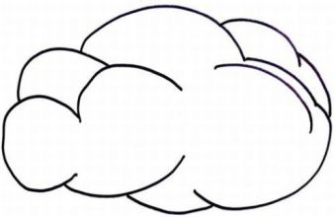 

**___________________________________________________________**

22. Give any one danger of having long finger nails.

**___________________________________________________________**

23. How is a tongue useful to a person?

**___________________________________________________________**

24. Why do people wash hands with soap before eating food?

**___________________________________________________________**

25. Give any one danger of cutting trees.

**___________________________________________________________**

26. What happens to a balloon if the stone is left on it for a long time.

**___________________________________________________________**

27. What is air?

**___________________________________________________________**

28. How do we keep the toilets clean?

**___________________________________________________________**

**The diagram below shows a tool used to keep proper sanitation. Use it to answer questions 29 and 30.**



29. Name the tool drawn above.

**___________________________________________________________**

30. How is the above tool useful when carrying out sanitation?

**___________________________________________________________**

31. What do we call the act of introducing vaccines into the body?

**___________________________________________________________**

32. Why do people keep domestic birds?

**___________________________________________________________**

33. State one danger of accidents to people.

**___________________________________________________________**

34. Mention any one form of child abuse.

**___________________________________________________________**

35. How can a P.3 child keep her hair clean?

**___________________________________________________________**

**The diagram below shows a food storage facility. Use it to answer questions 36 and 37.**

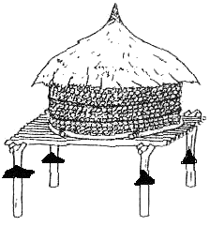

36. Write any one example of food kept in the above storage facility.

**___________________________________________________________**

37. Why do people keep food in the above storage?

**___________________________________________________________**

38. How is a water tank useful at home?

**___________________________________________________________**

39. Where does a fish live?

**___________________________________________________________**

40. Draw any one example of a fruit eaten at school.

**SECTION B**

41(a) Mention any two parts of a flowering plant. (i)______________________________________________________________

(ii)_____________________________________________________________

(b) State any one use of flowers to people.

**___________________________________________________________**

(c) How do people care for plants in the garden?

**___________________________________________________________**

42(a) Which clouds form rain?

**___________________________________________________________**

(b) Apart from the above mentioned clouds, mention any

other two types of clouds.

(i)______________________________________________________________

(ii)_____________________________________________________________

(c) How is rain from nimbus clouds useful to a farmer?

**___________________________________________________________**

43(a) State any two diseases spread by a housefly?

(i)______________________________________________________________

(ii)_____________________________________________________________

(b) How are spiracles useful to an insect?

**___________________________________________________________**

(c) Name any one example of winged insects.

**___________________________________________________________**

44. **The diagram below shows the property of air. Use it to answer the questions that follow.**

B

M C

(a) Name the property of air drawn above.

**___________________________________________________________**

(b) Name parts marked;

i) C**_______________________** ii) M**___________________________**

(c) Why is balloon **C** heavier than **B** ?

**___________________________________________________________**

45(a) What do we call the changes caused by human activities?

**___________________________________________________________**

(b) Mention any two examples of man-made changes.

(i)______________________________________________________________

(ii)_____________________________________________________________

(c) Write one reason why bush burning is a bad act.

**___________________________________________________________**

46(a) Give any two examples of utensils.

(i)______________________________________________________________

(ii)_____________________________________________________________

(b) How do we keep utensils clean?

**___________________________________________________________**

(c) How is a rack useful when washing utensils?

**___________________________________________________________**

47. **The diagram below is of a house. Use it to answer the questions that follow.**

**T**

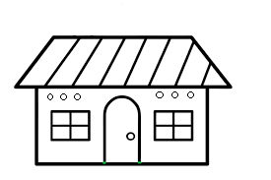

(a) Name part marked **T**.

**_________________________________________________**

(b) State the use of part **T** on the above building.

**___________________________________________________**

(c) Give one danger of lightning to people.

**____________________________________________________**

(d) How can we keep our houses clean ?

**___________________________________________________**

48(a) Name any one craft made out of;

i) banana fibres **_____________** ii) clay **____________________**

(b) How are these crafts useful to a P.3 child?

i) mats : **__________________________________________________**

ii) balls : **__________________________________________________**

49(a) What do we call the things which have life?

**______________________________________________________**

(b) State any two characteristics of living things.

(i)______________________________________________________________

(ii)_____________________________________________________________

(c) Why is a cow called a living thing?

**___________________________________________________**

50.  **Match the garden tool in A to its use in B.**

**A B**

a) hoe for slashing tall grass

b) slasher for weeding

c) watering can for collecting weeds and rubbish

d) rake for watering plants

**Correct order**

a) hoe **__________________________________**

b) slasher **___________________________________**

c) watering can **__________________________________**

d) rake **__________________________________**

51. **The diagram below shows a water source. Use it to answer the questions that follow.**

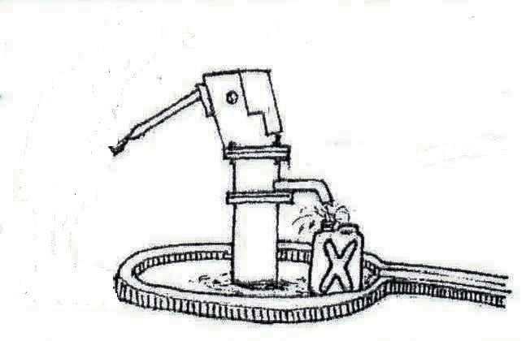

(a) Name the water source drawn above.

**__________________________________________________**

(b) How can we keep the above water source clean?

**____________________________________________________**

(c) Apart from the above mentioned water source, write any other two sources of water.

(i)______________________________________________________________

(ii)_____________________________________________________________

52(a) Write any two examples of common diseases.

(i)______________________________________________________________

(ii)_____________________________________________________________

(b) Why does a P.3 child sleep under a treated mosquito net at night?

**______________________________________________________**

(c) State any one danger of common diseases.

**_____________________________________________________**

53(a) Write the sound of these animals.

i) dog **__________________** ii) cat **__________________**

(b) Why do animals make sounds?

**_____________________________________________________**

(c) Which animal hisses?

**_____________________________________________________**

54. **The diagram below shows the layers of soil. Use it to answer the questions that follow.**

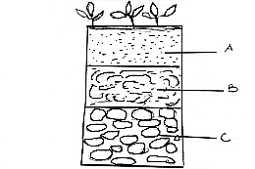

(a) Name the layers marked;

i)B:**_________________** ii) C: **________________**

(b) Which layer of soil is good for plant growth?

**___________________________________________________**

(c) Why is the above layer of soil good for plant growth?

**____________________________________________________**

55(a) Give any two examples of wild animals.

(i)______________________________________________________________

(ii)_____________________________________________________________

(b) State any two uses of wild animals.

(i)______________________________________________________________

(ii)_____________________________________________________________